Mobile Application Development
ICT TECHNICIAN LEVEL
IT/OS/ICT/CR/11/6
February 2026
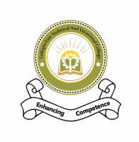
LAIKIPIA EAST TECHNICAL AND Vocational COLLEGE

PRACTICAL ASSESSMENT
Time: 3 Hours
Instructions to Candidates:
- Answer ALL questions.
- Use Android Studio.
- Programming language: Java
- Design layouts using XML.
- The app does NOT require internet connectivity.
- Proper naming conventions must be used.
- The app should be running on your phone
Task: Create a Simple “Student Profile” Mobile App
Objective:
Develop a basic Android application that displays student information.
Requirements:
- Create a new project in Android Studio.
- Design a layout using LinearLayout or ConstraintLayout.
- Add the following components:
  - TextView (App Title)
  - ImageView (Student Photo – use a drawable image)
  - TextViews (Name, Course, Year)
  - Button (“Show Message”)
- When the button is clicked, display a Toast message saying:
"Welcome to Mobile App Development!"

